William Jewell College
Faculty and staff campaign

NAME: Click or tap here to enter text.

DEPARTMENT: Click or tap here to enter text.

POSITION: Click or tap here to enter text.

I wish to join the Faculty and Staff community investing in our students with my gift to:
☐ Jewell’s Greatest Need (Jewell Fund)
☐ Cardinal Athletic Club (Athletics)
☐ Harriman–Jewell Series
☐ Nursing Excellence Alumni Scholarship

☐ Other:

My gift(s) to Jewell will be made as a:
☐ Monthly deductions of $ ☐ One-time deduction of $

☐ Payroll Deduction* ☐ Credit Card**
☐ Visa ☐ MasterCard ☐ Discover ☐ American Express
Name on Card:Click or tap here to enter text.
Card #: Click or tap here to enter text.
3-Digit CID# Exp. Date Click or tap here to enter text.
☐One-time gift of $ by Check made payable to William Jewell College.
☐ As a sustaining member, I/we wish to join the: ***
☐ John Priest Greene Society through my annual support of the Jewell Fund.
☐ J Club through my annual support of the Cardinal Athletic Fund.

This gift is being made:
☐ as a joint gift. Please recognize us as Click or tap here to enter text.

☐ anonymously.

☐ My spouse works for a matching gift company. Please contact me for more details.

Signature: Click or tap here to enter text. Date: Click or tap to enter a date.
*Deduction(s) begin on the next pay period upon receipt unless otherwise specified.
**Deduction(s) begin on the 15th of the next month upon receipt.
***Annual giving levels are shared on the back of this form.
William Jewell College
Faculty and staff campaign

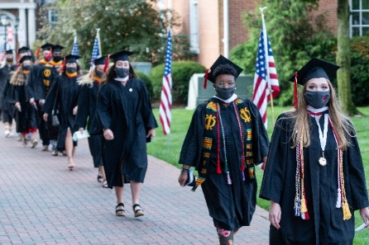
Thank you for considering a gift to Jewell. Your work makes a difference daily for our students, campus, and community. Without you, Jewell would not be a transformative place. Thank you for your part in advancing Jewell.

Annual Giving Societies

Jewell Fund
Supporting the greatest needs of the College. The Jewell Fund impacts every aspect of campus life and student support at Jewell.

John Priest Greene Society
Leadership donors who share an annual commitment of $1,000 or more to the Jewell Fund in support of the advancement of Jewell’s mission.

Founders Circle $5,000 - $9,999
President’s Circle $10,000 +

Cardinal Athletic Fund
Supporting the enhancement of Jewell’s student-athlete experience, including sports medicine, strength and conditioning, equipment management, and recruitment.

J Club
A network of alumni, families, and friends committed to advancing Cardinal Athletics with an annual commitment of $500 or more to the
Cardinal Athetlic Fund.

Fan Club $500 - $999
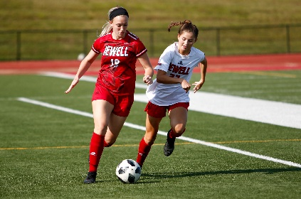
Varsity Club $1,000 - $2,499
Captains Club $2,500 - $4,999
Cardinal Club $5,000 - $9,999
Champion Circle $10,000 +

Please send your completed form to Rachel Addington, Director of Annual Giving at addingtonr@william.jewell.edu or through interoffice mail to the Office of Institutional Advancement Box 1032

